Question week 1

This question is based on the paper `De Reuver, M., Molina, F. J., & Bouwman, H. (2017). Business model innovation design and experimentation in SMEs: drivers and outcomes. Working paper.’

Although business model innovation has been receiving increasing attention in strategic management literature, there are no empirical studies into the effects of business model experimentation on firm performance. Business model experimentation means purposive efforts to try out new business models. In this paper, we examine the antecedents and consequences of business model experimentation using a representative quota sample of European SMEs. We find that business model experimentation has a significant impact on the performance of SMEs. Whether companies conduct business model experimentation depends on several things: their strategic orientation, competition intensity and technology turbulence.

1. Formulate a hypothesis, based on the abstract above. The hypothesis should involve a mediation effect (2 points)

Answer:

* One hypothesis (tentative statement) that links strategic orientation / competition intensity / technology turbulence to business model experimentation, and also links business model experimentation to firm performance (2 points)
  + Example 1: Strategic orientation affects business model experimentation, which in turn affects firm performance
  + Example 2: The effect of strategic orientation on firm performance is mediated by business model experimentation
* It does not matter whether the hypothesis is phrased directionally or non-directionally

Incorrect:

* Hypothesis is a question, not a statement (0 points)
* Moderation hypothesis (e.g. Business model experimentation affects firm performance, especially for firms with high competition intensity) (0 points)
* Only a main effect (e.g. Business model experimentation affects firm performance)

Question week 2

This question is based on the paper `De Reuver, M., Molina, F. J., & Bouwman, H. (2017). Business model innovation design and experimentation in SMEs: drivers and outcomes. Working paper.’

Although business model innovation has been receiving increasing attention in strategic management literature, there are no empirical studies into the effects of business model experimentation on firm performance. Business model experimentation means purposive efforts to try out new business models. In this paper, we examine the antecedents and consequences of business model experimentation using a representative quota sample of European SMEs. We find that business model experimentation has a significant impact on the performance of SMEs. Whether companies conduct business model experimentation depends on several things: their strategic orientation, competition intensity and technology turbulence.

2a. Formulate a questionnaire item for the construct `business model experimentation’. The questionnaire item should have a Likert scale. In your answer, include the wording of the item as well as the answer categories (2 points)

Answer:

* Any statement that somehow relates to efforts to try out new business models, with answer categories (Completely) Disagree – (Completely) Agree (2 points)
* Example: Our company experiments with new business models   
  Completely disagree ….. Completely Agree
* Example: We often try out new ways to earn money

Disagree …. Agree

Incorrect:

* Answer categories (Disagree / Agree) are missing (-1)
* The statement is vague, double-barred, ambiguous (-1)
* The statement is longer than 20 words, or actually contains multiple statements in one (-1)

2b. Suggest a way to evaluate the face validity of the questionnaire item you suggested (1 point)

Answer

* Any reasonable way to verify that the questionnaire item indeed looks like it covers the construct (1 point)
* Example: Ask a group of business model experts whether the item indeed seems to cover the idea of business model experimentation

Incorrect:

* Answers related to other forms of validity. Examples
  + whether the item can be used to distinguish companies
  + whether the item correlates with other items that are about the same construct
  + whether the item does not correlate with other items that are about different constructs
* Answers related to other forms of reliability. Examples
  + Whether the item works similarly in different settings / points in time
  + Whether the item is free from bias

## *Case study design (3 points)*

Q: Robert Yin (2018) mentions four main criticisms on case study research. Mention two of these four criticisms and provide a solution to deal with both of these criticisms (max 150 words).

Correct answer

Two of the following four criticisms and one of the four oppositions.

* Criticism: Lack of rigor. “Perhaps the greatest concern has arisen over a presumed need for greater rigor in doing case study research. Too many times, a case study researcher has been sloppy, has not followed systematic procedures, or has allowed equivocal evidence to influence the direction of the findings and conclusions. In doing case study research, you need to avoid such practices.” (Yin) (1 point)
  + Opposition: Systematic procedures need to be used to avoid sloppy practices. Development and implementation of case study protocol. (1 point)
* Criticism: Little basis for generalization. “How can you generalize from a single-case study?” is a frequently heard question. (1 point)
  + Opposition: “Case studies, like experiments, are generalizable to theoretical propositions and not to populations or universes. In this sense, neither the “case” nor the case study, like the experiment, represent “samples.” Rather, in doing case study research, your goal will be to expand and generalize theories (analytic generalizations) and not to extrapolate probabilities (statistical generalizations).” (Yin) (1 point)
* Criticism: Unmanageable level of effort, take much time. A frequent concern about case study research is that case studies can potentially take too long and result in massive, unreadable documents. (1 point)
  + Opposition: Case studies do not necessarily take an unmanageable level of effort or too much time. Yin: “This incorrectly confuses case study research with a specific method of data collection, such as ethnography or participant-observation. However, case study research is a form of inquiry that does *not* depend solely on ethnographic or participant-observer data. (1 point)
* Criticism: Too much detail, getting lost in materials. Case studies typically have many points of interest and combine multiple information sources. (1 point)
  + Opposition: Use systematic procedures. Use theoretical propositions to guide the search for data within the case. (1 point)

It is also fine if students mentioned one of the five case study misunderstandings as described by Flyvbjerg: 1) theoretical knowledge is more valuable than practical knowledge; 2) one cannot generalize from a single case, 3) the case study is most useful for generating hypotheses, not for testing them, 4) the case study contains a bias toward verification, 5) it is often difficult to summarize specific case studies), as long as they formulate them as a criticism and oppose one of the criticisms using argumentation from lecture 4a, video 3 (slides 17-21).

Point assignment

0,5 point for each criticism (max 1 point) + 1 point for each correct solution to deal with the criticism (max 2 points).

Incorrect answers / point reduction

- No solutions are mentioned.

- Solutions are mentioned only for one of the criticisms, not for both of them. - The mentioned solutions do not relate to the mentioned criticisms.

- Three criticisms without a solution.

## *Qualitative analysis / coding (2 points)*

Q: Explain two out of the three main steps to be taken in the qualitative data analysis. Explain each step in 2-3 sentences (max 120 words).

Correct answer:

Two out of the following three steps of qualitative data are mentioned *and* explained:

1. Step 1: Data reduction.
   * Explanation: The first step in qualitative data analysis is concerned with data reduction. Data reduction refers to the process of selecting, coding, and categorizing the data.
2. Step 2: Data display.
   * Explanation: Data display refers to ways of presenting the data. A selection of quotes, a matrix, a graph, or a chart illustrating patterns in the data may help the researcher (and eventually the reader) to understand the data. In this way, data displays may help you to draw conclusions based on patterns in the reduced set of data.
3. Step 3: Drawing conclusions.
   * Explanation: Having identified these general stages, it should be noted that qualitative data analysis is not a step-by-step, linear process but rather a continuous and iterative process. For instance, data coding may help you simultaneously to develop ideas on how the data may be displayed, as well as to draw some preliminary conclusions. In turn, preliminary conclusions may feed back into the way the raw data are coded, categorized, and displayed.

Point assignment

Max 2 points. (Source S&B + slides)

* If one correct step is mentioned but not explained properly 0,5 points are given.
* If one correct step is mentioned and explained properly 1 point is given.
* If two correct steps are mentioned, but not explained properly 1 point is given.
* If two correct steps are mentioned and explained properly 2 points are given.
* If two correct steps are mentioned, but only one is explained properly 1,5 points are given.

Incorrect answer

- The steps mentioned are incorrect.

- The step is not explained at all

- The step is not explained properly, e.g. using vague terms.

**Question 1 (total score 3 points)**

Researchers investigated the impact of two personality traits (BIS and BAS) on a person’s susceptibility to Generalized Anxiety (GA). Two (alternative) hypotheses were tested:

*Hypothesis 1*: People high (vs. low) in BIS are more susceptible to Generalized Anxiety (GA).

*Hypothesis 2*: People high (vs. low) in BAS are more susceptible to Generalized Anxiety (GA).

1. On the next page, you find the JASP output of a regression analysis for this study. Do we accept or reject (alternative) *Hypothesis 1*? [open question; **0.5 point**]. Use the JASP regression output to motivate your answer [open question; **1 point**].

* We **reject** Halt that people high (vs. low) in BIS are more susceptible to generalized anxiety (GA) --> [**0.5 point** for correct answer], because:
* We have: p < .001. The associated **p-value is less than .05** (Hypo1alt thus is significant) --> [**0.5 point** for correct answer].
* Unfortunately, we also have: t = - 5.817. The **t-value is negative, whereas the hypothesis predicted a positive effect** (this is in the wrong direction) --> [**0.5 point** for correct answer].
* Also we have

1. Do we accept or reject (alternative) *Hypothesis 2*? [open question; **0.5 point**] Use the JASP regression output to motivate your answer [open question; **1 point**].

* We **reject** Halt that people high (vs. low) in BAS are more susceptible to generalized anxiety (GA) --> [**0.5 point** for correct answer].
* We have: t = + 1.631. The **t-value is positive** as hypothesized --> [**0.5 point** for correct answer].
* However. We also have p < .105. The associated **p-value is bigger than .05** (Halt thus is not significant) --> [**0.5 point** for correct answer].

**JASP Regression Output for Question 1**

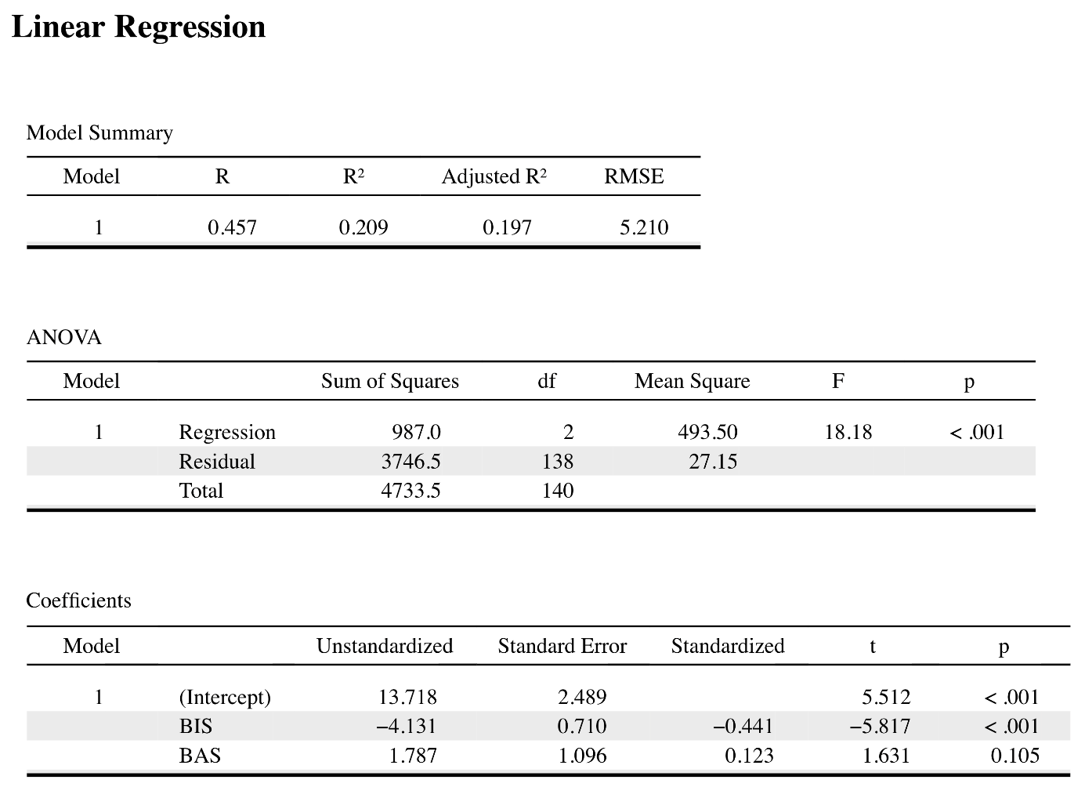

**Question 2 (total of 3 points)**

Below you find a brief description of a prize-winning study by:

Bennett, C. M., Baird, A. A., Miller, M. B., & Wolford, G. L. (2009). Neural Correlates of Interspecies Perspective Taking in the Post-Mortem Atlantic Salmon. *NeuroImage, 47*, S125.

Brief description:

One mature Atlantic Salmon participated in an fMRI study. The salmon was approximately 18 inches long, weighted 3.8 lbs, and was not alive at the time of scanning. The task administered to the salmon involved completing an open-ended mentalizing task. The salmon was shown a series of photographs depicting human individuals in social situations with a specified emotional valence. The salmon was asked to determine what emotion the individual in the photo must have been experiencing. Statistical analysis showed significant activation within the salmon’s brain. The authors did not conclude that the dead salmon was engaging in perspective taking. The researchers used this study to warn researchers to always control for the random noise in fMRI equipment, and to not analyze data without proper calibration.

1. Bougie and Sekaran, in their research methods book, describe seven (7) threats to internal validity in experiments. Which one (1) of those seven threats best applies to what the authors reported on the dead salmon in the fMRI study? Motivate your answer [open question; **1.0 point**]?

* The study pointed to **instrumentation effects** in fMRI equipment --> **0.5 point** for mentioning this correctly.
* Explanation: Instrumentation effects describe erroneous final measurements due to lack of calibration of physical instruments and/or other measurement instruments. Here, random noise in the fMRI scanner seemed to suggest that a dead salmon engaged in perspective taking ----> **0.5 point** for (some) mentioning of this principle (needs not be literary).
* The goal of this study was **prediction** --> **0.5 point** for correct answer (no explanation needed)
* (a) The authors wished to learn how to predict two forms of behavior (past vs. future-oriented thinking) in (b) naturally occurring groups --> **0.5 point** for providing either (a) or (b) in some form.

1. According to Bougie and Sekaran, which other six (6) threats may interfere with internal validity in experiments? List and briefly describe each of them [open question; **2.0 points**]?

* History effects (when unexpected events interfere with the independent-dependent variable relationship at test), maturation effects (cause-an-effect is contaminated by effects of the passage of time [tired, hungry, thirsty, getting bored]), testing effects (when prior observation interferes with later behavior [i.e., consistent answering also at post-test]), selection bias (improper participant selection), mortality effects (confounds due to participant drop-out), statistical regression effects (regression towards the mean) --> **1/6 point** per correct effect **+ 1/6 point** per correct description

**Question 3 (total of 3 points)**

A descriptive analysis of the 6 dimensions of the Susceptibility to Persuasion Scale (SPS) yields the following JASP output.

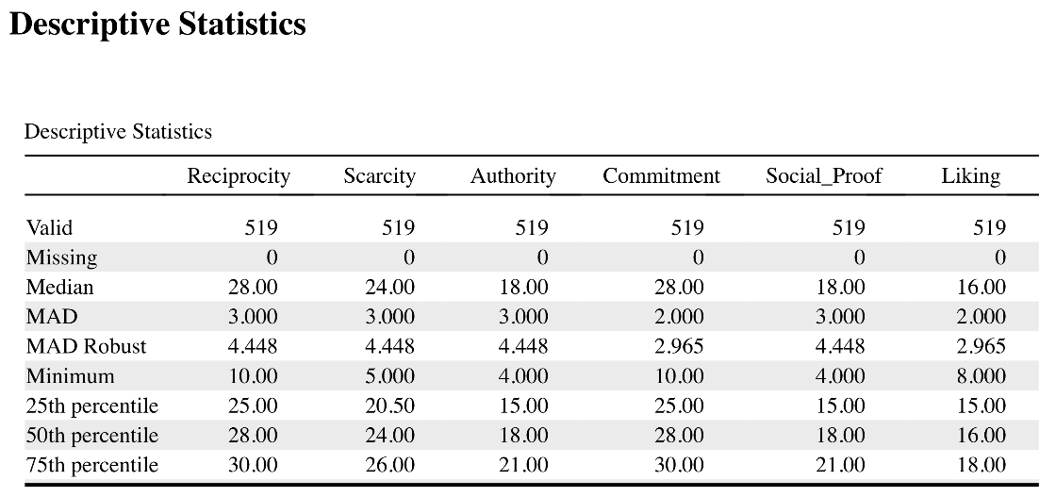

1. Which numerical measures of variation are summarized in this JASP output for the SPS [open question; **1 point**]?

Correct answer is: **Minimum** **range** is the only measure of variation reported in the table --> **1.0 point**, if correct).

Incorrect answers are: All other measures are incorrect (none was discussed in the lectures / the textbook) --> **0.0 point**

1. Which numerical measures of central tendency are summarized in this JASP output for the SPS [open question; **1 point**]?

Correct answer is: The **median** is the only measure of central tendency reported in the table --> **1.0 point**, if correct).

Incorrect answers are: All other measures in the table, as they are incorrect --> **0.0 point**

1. Theoretically, what can you say about the sensitivity of the median to extreme values [open question; **1 point**]?

Correct answer is:

* The median is **NOT very sensitive to extreme** values (because its value is determined by position in the distribution) --> **1.0 point**, for stating “NOT sensitive” (explanation in brackets is great, but not needed for full score).

**Question 4 (total of 3 points)**

Below you find a correlation analysis of a Technology Acceptance Model, in which all variables (PE, EE, SI, BI) are interval / ratio. The nominal and dichotomous variable Gender is also added to the correlation matrix. This yields the following JASP output.

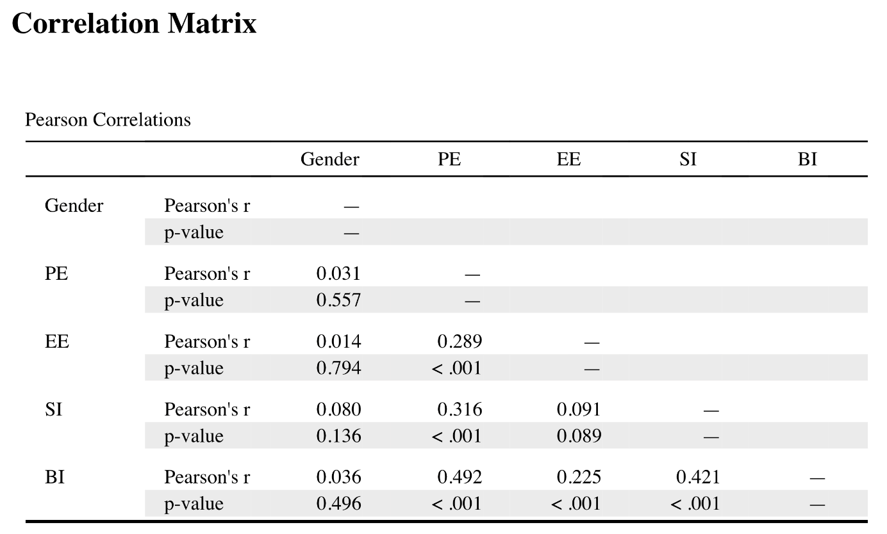

1. How many *moderately strong* bivariate correlations are summarized in the matrix? Identify the pairs [open question; **1.5 points**].

Correct answers are:

Correlations between |.30, .69| are of moderate strength. Here, we have this **three times**, for:

* SI – PE (r = .316) --> **0.5 point** for providing this pair
* PE – BI (r = .492) --> **0.5 point** for providing this pair
* SI – BI (r = .421) --> **0.5 point** for providing this pair

Incorrect answers are:

* To provide the correct pairs (see above), without a correct legitimization, within a large list of incorrect pairs --> **0.0 point**
* To present your pairs based on their p-values rather than on the (requested) r-magnitudes --> **0.0 point**

1. It is not appropriate to use the Pearson’s correlation coefficient to calculate correlations between the TAM variables (PE, EE, SI, and BI) and Gender in this output. Explain why not? What would be a better approach [open question; **1.5 points**]?

* Acc. to the introduction, TAM variables are interval / ratio measures, whereas Gender is nominal / dichotomous. In such cases, Pearson’s correlations should not be used [--> **1.0 point**; for this observation]
* The book advices to use **Point-Biserial** correlation coefficients in such cases [**0.5 point**; for this observation]